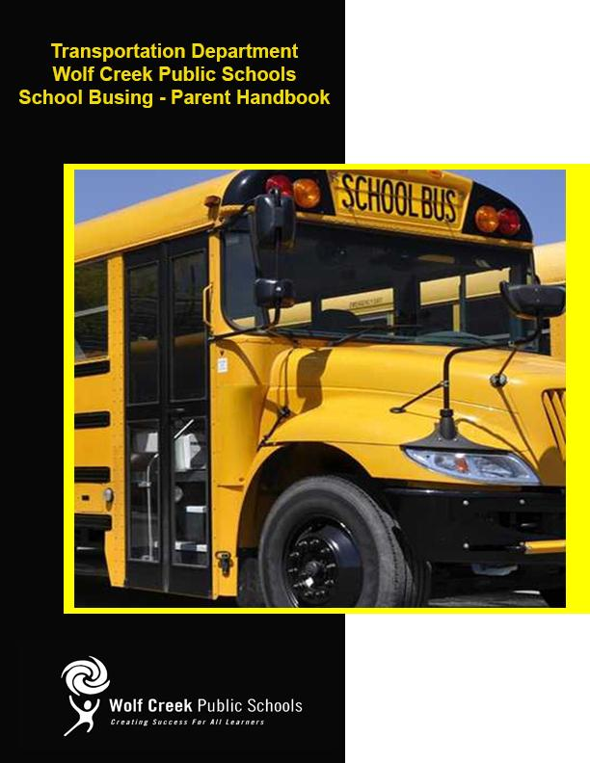
2023-2024
CONTENTS

Objective ………………………………………………………………………………………. 3
Regulations …………………………………………………………………………………… 4
Rural Students ……………………………………………………………………………….. 4
School Boundaries ………………………………………………………………………….. 4
Urban Students ………………………………………………………………………………. 5
Eligible Students …………………………………………………………………………….. 5
Non-Eligible Students ………………………………………………………………………. 5
Medical Alerts for Drivers ………………………………………………………………….. 6
Rules for Riding a School Bus ……………………………………………………………. 6
Starting Transportation …………………………………………………………………….. 7
Cross Boundary Students ……………………….………………………………………… 7
Grade Advancement ………………………………………………………………………… 7
Pick Up Times ………………………………………………………………………………… 7
Late For the Assigned Pick Up ……………………………………………………………. 8
Drop Off Times ……………………………………………………………………………….. 8
Bus Route Status Online (BUS STATUS APP) …………………………………………. 8
Seat Assignment …………………………………………………………………………….. 10
Temporary or Emergency Transportation on School Bus …………………………… 10
Video Surveillance …………………………………………………………………………… 10
School Bus Loading and Unloading ………..…………………………………………….. 11
Frequently Asked Questions ………………………………………………………………. 12
Transportation Services – Contact Information ………………………………………... 15

OBJECTIVE

Wolf Creek Public Schools Transportation Services main objective is, to ensure that students are transported to and from school safely. The safety of students is contingent, in large part, upon student behavior. It is necessary to establish general rules to set a standard to judge acceptability of behavior on the bus and to enforce those rules in the interests of the safety of students. The school bus is considered an extension of the classroom and, therefore, classroom conduct is to be observed at all times. The bus driver is responsible for the students on his/her bus and must, therefore, receive the respect, consideration and co-operation of each student. Your bus driver is required to implement the rules established by the Wolf Creek School Division, the Education Act and the transportation laws set by federal and provincial governments. Students riding on a school bus are under the immediate supervision and authority of the driver from the time they are loading until they are discharged at the school and, similarly, on the afternoon return trip. The following paragraphs highlight some of the issues that pertain to the safe transportation of students. Your co-operation in reviewing these issues with your student(s) will be appreciated.

This Student Transportation Parent Handbook was developed to assist in understanding Wolf Creek Public Schools (WCPS) busing system.

The Education Act (Act) provides that a school board shall, in accordance with the regulation, provide for the transportation of a student who:

- Resides within the attendance area of the school in which the student is enrolled.
- Resides within the division boundary; and
- Resides at a distance greater than the distances outlined in the Province of Alberta’s Education Act.

The Act allows the School Division to levy a fee for transportation services if a family requires busing and lives inside of the prescribed distances or if a family lives outside of the Wolf Creek boundary. For fees and further information pertaining to recent changes to the distances outlined the Education Act, please visit: https://www.wolfcreek.ab.ca/school-division/transportation/bus-status-page2

REGULATIONS
The school bus service provided by Wolf Creek Public Schools (known as the Division) is regulated by the Education Act and Student Transportation Regulation, the Traffic Safety Act, the rules of the road and other pertinent legislation struck to provide guidance for order and safety. The actual service levels are determined by the Board. The Board is responsible to set the guidelines and directs the Superintendent in all matters of educational services. The Board has established board policies to define the directions given; and the Superintendent maintains administrative procedures reflective of the operational direction of the Board.
The Transportation Department works within this policy and procedure framework. The Generally Accepted Practices and Procedures for busing within the Division has been recorded in The Driver’s Orientation Manual. This document forms the basis of our transportation program.

RURAL STUDENTS

There are no fees for Rural students unless categorized as Cross Boundary busing. If an urban student lives less than the distances outlined by Alberta Education, they may fall into a “User Pay” category. To view current User Pay busing fees please visit https://www.wolfcreek.ab.ca/school-division/transportation/bus-status-page2
Students living within the defined boundaries of the Division have access to the transportation system as required under the School Act. Currently for the 2023-2024 school year, to be eligible for busing services, students must live 2.4 kilometers or further from their designated school. Please refer to the Education Act for upcoming changes to these distances which has been delayed for the start of the 2025-2026 school year. Wolf Creek Public Schools reserves the right to accommodate new distance regulations for the upcoming school year where capacity permits. Special arrangements may be made for students with exceptional requirements.
Alberta Education Act student eligibility changes for the 2025-2026 school year are as follows:
- Students ages K-6 and live 1 km or further from their designated school, will qualify for free busing.
- Students ages 7-12 and live 2 km or further from their designated school, will qualify for free busing.
Rural students will be picked up/dropped off at their home residence or a predetermined collection point. Except where the parent, or legal guardian has made a special application under the guidelines of Administrative Procedure 560 - General Transportation of Students. (Conditions apply).

SCHOOL BOUNDARIES
School attendance boundaries are established by the Board as required under the Education Act. Students are transported to their designated school within the attendance boundaries that they reside in.
School of Choice
Under the Education Act, parents have the freedom to choose a school other than the designated school of attendance for their students. If a family decides to attend a school other than the Division’s designated school, the Board is not required to provide transportation for the student to the school of choice. Students may still access division buses as a Cross Boundary Student; however, these rules must be followed:
- The student must be accepted at their school of choice.
- The student must meet the school bus at an existing designated bus stop as determined by the Transportation department operating within the attendance area for the chosen school (Note: this location may change should the route change);
- There must be room on the bus; and
- The student must apply by filling in an on-line busing application through School Engage\Parent Portal and state that they are requesting cross boundary transportation. There is an administrative fee that is tied to this type of bus request (this fee is set by the Board). Once the application is received and processed you will be required to submit the application fee for the application to go forward. You will then be sent a Cross Boundary Agreement to sign, only after this is signed and fees submitted will the student be able to access busing.

URBAN STUDENTS
Urban (town) students who live in the towns of Lacombe, Blackfalds or Ponoka MUST re-register each year - students will not be permitted to ride until the application has been approved and busing is paid for or payment arrangements have been made if it is determined your home is in a user pay area. All addresses are checked and verified. There is a transportation fee for town students who live less than 2.4 kilometers from their school.
Urban students may be categorized as Eligible if they live 2.4 kilometers or more or non-eligible if they live less than 2.4 kilometers from their designated school. These distances are calculated and verified by WCPS Transportation Services mapping systems.

Please refer to the Education Act for upcoming changes to these distances which has been delayed until the start of the 2025-2026 school year. Wolf Creek Public Schools reserves the right to accommodate new distance regulations for the upcoming school year where capacity permits. Special arrangements may be made for students with exceptional requirements.

Alberta Education Act student eligibility changes for the 2025-2026 school year are as follows:
- Students ages K-6 and live 1 km or further from their designated school, qualify for free busing.
- Students ages 7-12 and live 2 km or further from their designated school, qualify for free busing.

ELIGIBLE STUDENTS
Current Eligible students (those who live 2.4 kilometers or further from their designated school) will be registered first at no cost to the student. The Transportation Department must receive a request for busing from eligible students by June 15 in the school year in order to guarantee eligible students a seat. Online registration is the only way to apply for busing.

NON-ELIGIBLE STUDENTS
For students living closer than 2.4 kilometers (non-eligible) from their designated school in the Towns of Blackfalds, Ponoka and the City of Lacombe, the Board provides an in-town busing service on a “user pay system”. Our buses have limited seating and we may not be able to fill all requests. All requests are put onto a “Waitlist,” requests are filled on a “first-come, first-served” basis so you are advised to register early.
Again, please refer to the Education Act for upcoming changes to these distances which have been delayed for the start of 2025-2026 school year. Wolf Creek Public Schools reserves the right to accommodate new distance regulations for the upcoming school year where capacity permits. Special arrangements may be made for students with exceptional requirements.
There is a fee for transporting non-eligible students (user pay), this fee must be paid in full, or payment plan arrangements made through Rycor Student Fees system (at the beginning of the school term only) as approved by the Board. These fees or payment plan setup must be made prior to the student riding the bus. Please note these seats are sold on a first come, first served basis. New students arriving during the school year to a user-pay area may receive a prorated fee. Please visit the Transportation Services webpage on the Division website or contact the Transportation office for details.
The Division can only provide transportation to one registered bus stop. We will not conduct pickups or drop offs at multiple locations. (i.e. home address on Monday, Grandparents on Tuesdays, and daycare the rest of the week or to two different parent addresses).

Medical Alerts for Drivers
Parents of students with special requirements need to inform the driver and the Inclusive Learning Services Department at the Division office of the student’s needs. Medical conditions, allergies, or other concerns should be relayed directly to the driver. Parents should provide the driver with all relevant details that could affect the ride to and from school. Please do not assume that the driver has important information about your child unless you have instructed them yourself. This information about your child will be kept confidential and will only be used to inform the drivers of your child’s particular bus.

Rules for Riding a School Bus
Responsibilities
The rules for riding a school bus are provided on a Responsibility Card which is available on the Transportation Services webpage of the Division website. The responsibility cards detail the student’s, the parent’s, and the driver’s responsibilities.
Drivers distribute these cards (one per family) to students on their bus at the beginning of the school year. There is a tear-away section that the driver keeps for their records. Parents are required to sign these cards and return them to the driver. The parent’s signature should indicate that the parents and the students know and understand the rules for the bus and that they will adhere to these rules.

Discipline
The driver will deal with any issues that arise on the bus. Drivers have a great deal of experience and expertise in getting students to behave on the bus. Occasionally, drivers face situations where encouragement of proper student behaviour is not successful. In these cases, the driver will request assistance from the parents. Parental support is very helpful in dealing with behaviour modification. If the phone call home is not effective in dealing with the situation, the driver will start to record incidents formally and seek the school administrator’s support. The form used to detail these issues is the Student Misconduct Report.

Student Misconduct Report
The Student Misconduct Report details the behaviour that requires adjustment. The report is given to the Principal who is responsible for student discipline. The Principal will take whatever action they deem necessary to correct the student's behavior so that the bus remains a safe place for all students as well as the driver.
The Principal will provide a response in writing to the Transportation Department on the Misconduct Report. The Transportation Manager will relay the Principal’s action advice to the driver. In most cases, the Principal and the driver will communicate directly with respect to the punitive portion of the disciplinary action process.
The Principal has the authority under the School Act to remove a student from the bus for up to five days. Repeated misconduct detrimental to the safety of other passengers or the driver may result in expulsion from the bus.

Cross Boundary Students – Evening Drop Off
Younger cross boundary students will not be dropped off at their designated location if there is no one there to meet the student at the assigned drop off time. Drivers are instructed to return students to the school at the end of their route. If the school is closed and the Principal cannot be located, the driver will deliver the student(s) to the local RCMP detachment.
Please keep your bus driver’s phone number handy for emergency situations and have a backup plan available. Discuss this plan with your children.

Starting Transportation
All transportation registrations must be completed within School Engage
All registration forms are accessible through your PowerSchool Parent Portal. Please use School Engage to submit an application for bus transportation.
Register your student(s) online as early as possible to ensure your request is received in time for transportation services to take effect.

Grade Advancement
For Rural busing, if you are already registered with the Transportation Department and your child will continue at your designated school, your child will be automatically grade advanced each year.
For Urban (In-Town) busing (Blackfalds, Ponoka & City of Lacombe), an online registration is required each year. This is also required for Blackfalds to Lacombe high school students, who are not currently registered for busing in the Blackfalds area. Urban STAR Catholic students also need to reapply each year.

Pick Up Times
At the start of the school year, the driver will contact each family and inform them of their morning pick up time. The bus routes will be reviewed for efficiencies throughout the months of September and October. The pickup times will be finalized by the drivers as quickly as possible. However, adjustments can occur throughout the year due to changes in the route if ridership changes or other factors. Instances when a route is changed and impacts the pickup/drop off times, the driver will notify the parents of any changes.

Late For the Assigned Pick Up
Students are expected to be at the stop, ready to board the bus 5 minutes before their assigned pick-up time. If your child/children are late, you must have a contingency plan to get them to school. The driver will leave your stop at the assigned time. (If everyone on the bus were late by one minute the bus would arrive approximately 30 minutes late). Please be on time. Also, have a contingency plan in place in case the bus does not arrive. (For example, sometimes a bus may have a mechanical difficulty mid-route and cannot complete their pickups). Parents should have a plan on what to do if the bus does not arrive.

Drop Off Times
Generally speaking, drop-off times need to be somewhat flexible. Routes can be shortened due to student absences in the afternoon. This may get your child home early. Plan or establish a contingency plan for this situation.

Bus Route Status Online
To keep updated as to whether your child’s bus may be running late or cancelled please visit the Bus Status webpage on the Division’s website to view its status. You may also download our “Bus Status” app for your phone to receive notifications and the status of your child's bus.

- Statuses are linked on your child’s school website as well.
- Statuses will be updated online as they become available.
- Reasons for a bus status update can include, but are not limited to the following reasons.
  - mechanical issues, poor roads, or visibility, held up at a train crossing, bus getting stuck, etc.
- Delay times indicated are based on an approximate time frame and may vary depending on the circumstances.

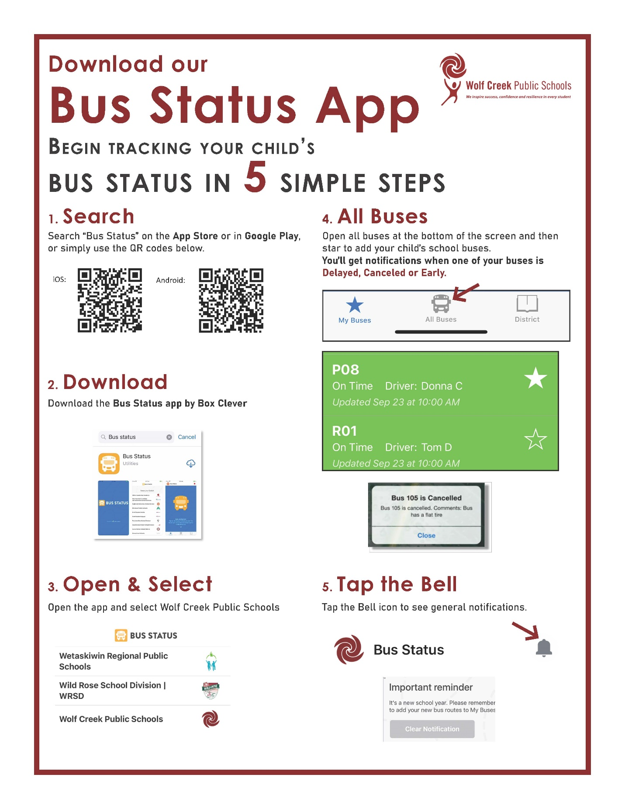

The Family Pets
It is the responsibility of the family to ensure that family pets are kept away and clear of where the bus pulls up to load/unload students.

Seat Assignment
The driver has the sole responsibility to develop a seating plan and each student shall sit in the assigned seat. Students have the responsibility to accept the seat specifically assigned by the driver. Students will sit in their assigned seat at all times unless authorized by the driver. Sometimes due to behavior issues drivers will move students to different seats in an attempt to resolve the issue.

Use of Personal Phone, Audio Device, Tablet, etc.
Students are not permitted to play an electronic device or cellphone that plays sound without earphones while on the bus. Any apparatus that is operated with the use of earphones shall be operated at a level that ensures that the sound does not affect other passengers nor interfere with the driver’s ability to communicate with the students on the bus. It is the student’s responsibility to take care of these items when used on the bus.

Proper Winter Attire
All students riding on a school bus during the winter months are required to be prepared for unexpected severe weather conditions. Students must carry with them appropriate winter footwear, outerwear, headwear and gloves/mitts.

Temporary or Emergency Transportation on School Bus
This is limited to Wolf Creek School Division bus users and is only to be used as a last resort for emergency situations. The student must be a registered bus user, and space has to be available on that bus. The trip MUST be authorized by the Transportation Office working in conjunction with the school administration. After careful consideration of the circumstances, a decision will be made, and the necessary parties informed and route totals adjusted.

Video Surveillance
Many Wolf Creek School buses are equipped with video surveillance equipment. The equipment is being used as a measure to enhance the safety and security of individuals and property of Wolf Creek School Division No 72. The equipment records both audio and video images, if you have any questions regarding the use of cameras, etc. please contact Transportation Services at 403-785-0726. You may also refer to Admin Procedure 182 on the Transportation website.

SCHOOL BUS LOADING AND UNLOADING

The most dangerous part of the school bus ride is getting on and off the school bus. The loading and unloading areas are called the “Danger Zone”.

The “Danger Zone” is the area on all sides of the bus where children are in the most danger of not being seen by the driver (three meters in front, three meters on either side of the bus, and three meters behind are all areas where a child may be in the driver’s blind spot). It only takes a second to lose sight of a student if a driver becomes distracted by students on board the bus.

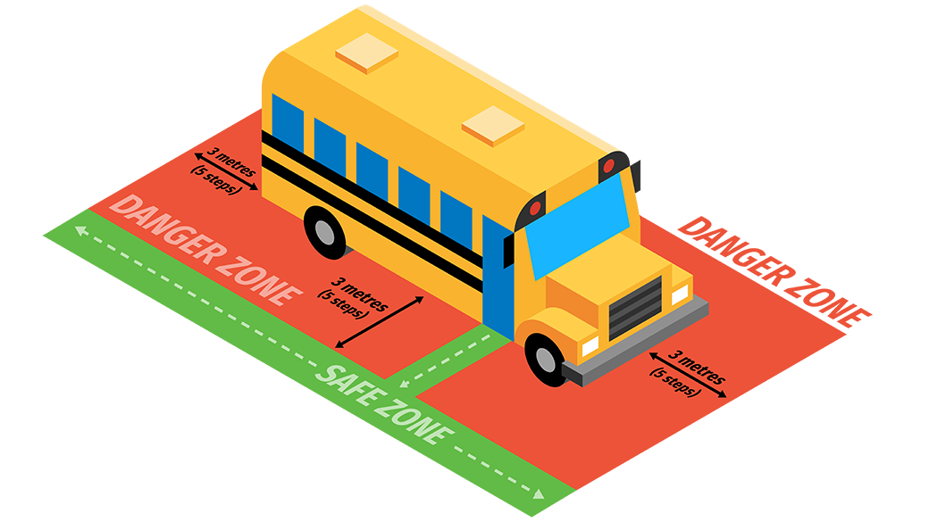

When training our bus drivers, we stress the importance of safe loading and unloading procedures. This is where our drivers need to be fully focused and cannot be distracted by students or parents. This is not the time to have a conversation with the driver. If parents need to communicate with the driver, please do so at a different time.

It is important to have parents understand that drivers need their cooperation to be fully focused at this time, by not parking in and staying away from the loading and unloading zones. Please park well away from loading zones at all times.

It is also important to instruct students in the proper procedure for loading and unloading.

- Be cautious when carrying loose papers or books which might drop near the bus – we
encourage students to use a book bag.
- Be aware of the dangers of clothing, book bag, backpack, and jacket strings/straps that could become entangled in the doorway of the school bus.
- Wait in an orderly fashion safely back from roadway or pick-up zone. Students need to be at their stop five minutes early. The time you have been given for departure is the time the bus departs from your stop.
- Board the bus in single file; use the handrail so you don’t trip on the steps.
- Sit down right away, so you don’t fall when the bus starts moving.
- Sit back in your seat, face forward and keep your feet to the front.
- Keep the aisle clear of feet, backpacks, books, etc.
- Talk quietly in order that you do not distract the driver. Remember, it’s the driver’s responsibility to keep you safe!
- Keep your head, arms, and hands inside the bus, not out the window.
- Never throw things in the bus or out the window.
- Wait for the bus to come to a complete stop and the doors to open before you leave your seat.
- After leaving the bus, take five giant steps away from the bus so you are out of the Danger Zone and in a safe spot.
- If you need to cross in front of the bus, make sure you look at the driver for a signal that it is okay for you to cross the roadway.

Frequently Asked Questions

Can I bring a friend home on the bus?

Guest Riders are not allowed on the bus

What is allowed on the bus as a carry on by the students?
According to the Highway Traffic Act, there are restrictions as to what may be brought on a bus. The School Board has adopted Administrative Procedure 562 . It outlines that hockey sticks, lacrosse sticks, large band equipment etc. cannot be brought on the bus. Skis, poles and snowboards as well as skateboards and the like would definitely fall into the items that cannot be transported on WCPS school buses. Other items would include large school projects, animals, firearms or weapons, explosives, flammable materials or substances. Items cannot block the aisle or emergency exits. Skates are permitted provided that blade guards protect the blades, and they are carried in a heavy tote bag and stored under the students’ seat.

Students are only allowed to bring materials on the school bus that will fit comfortably onto their lap; this would include a reasonable number of books, supplies or personal items. It is important to recognize that these materials should be contained in a backpack, but if that is not possible, they should be limited to a number that the student can easily control.

The backpack that the student brings onto the bus, and that sits on their lap, should be of a reasonable size. Our guidelines would require that it be a maximum size of 10” by 13” by 22”. The purpose of these measurements is to ensure that a backpack or “storage item” does not intrude on another student’s space, extend into the aisle or go over the height of the seat in front of them.

The student is also allowed to bring one additional item onto the bus that can fit comfortably under the seat that they occupy. This item cannot hinder another student’s foot space, nor intrude into the aisle.

  - The Transportation Department will enforce the rules based on a commonsense approach. If the item cannot fit and be secured on the student’s lap or under the seat, that item will not be allowed to be transported on the bus. The driver will send the student back to the school or to their home to make arrangements to have these items transported. If the item is questionable about it becoming a projectile while in transit, it will be refused. Do not expect large school projects to be allowed on the bus; these must meet the same size regulations as all other items. Be prepared to transport these items separately in your own vehicle.

  - For further information, refer to the Student’s Responsibility Card.

What should I do if my child complains about another student or a situation on the bus?
As a parent, the first action should be to contact the driver and discuss what you know about the incident. There is a good chance that the driver knows about it and is in the process of dealing with the issue. However, the driver may not know about the issue and so should be made aware of it. The successful resolution of any busing problem will come from effective communication.
The driver will involve the school at the appropriate time if necessary. Many issues have a way of working themselves out as the drivers are very resourceful in this regard. The schools will expect the driver to have tried solutions already and to have contacted the parents before the issue is brought forward. The exception to this rule is for serious incidents where the appropriate persons including the Principal and the Transportation Manager may be called into the situation immediately.
All issues are considered important and will be dealt with seriously and in a professional manner. Parents should feel free to discuss busing issues with school administrators.

How will I find out if the bus route is cancelled?
The Division will make an announcement regarding school closures due to weather by 6:30 a.m. on the day that closure is warranted. The Division sends drivers out to test conditions starting at 5:00 a.m. on days that weather is bad. The information gathered is compiled and a decision is made regarding the necessity of a school closure.
If buses do not run, schools may be closed. The only exception to this closure rule would be during diploma examinations or in conditions where improvement is expected throughout the day (i.e. such as early morning fog). Some weather delays will force the cancellation of buses in the morning but allow the students to safely get to school on their own and be transported home in the afternoon.
School closure announcements are carried on: CFCW, CHED, CKGY, ZED 99, CKJR, Big105 & The Drive, Cruz FM, CKJR, Sunny 94, Kraze101, Global/ITV, and the school and district websites.

PowerSchool Announcement/Swift Reach messages are also sent out via phone, text or e-mail depending on what preferences you have arranged at your child’s school.
Our new “Bus Status” app can also be downloaded and set up to send out notifications of bus status.
Parents should have a contingency plan in the event that buses do not operate, and schools are closed.

What should I do if my child will not be riding the bus?
Inform your child’s bus driver or contact the relevant bus shop to have them contact the driver by radio.
Have your student tell the driver beforehand or phone the driver yourself.
This is a courtesy that the drivers really appreciate.
Do not assume that the school will contact the driver.
Bus shop phone numbers are located on the last page of this document.

What is the appeal process?
Parents can appeal decisions made by Transportation Department personnel. The appeal should go to the Transportation Manager first and then to the Secretary Treasurer if the matter is not resolved with the Transportation Manager.

What special training do WCPS drivers have?
Wolf Creek Public School drivers are some of the best trained drivers in Canada. All drivers must provide a valid current driver’s abstract yearly, along with a clean criminal record check and child intervention check before they can be considered to drive for the Division. All drivers possess a minimum of a valid Class 2 driver’s license, along with the Alberta ‘S’ Endorsement (school bus driver improvement program) and or M.E.L.T certification prior to being allowed to drive a school bus.
Drivers attend professional development seminars each year. Drivers are required to maintain current First Aid, CPR certificates, and yearly medicals. Drivers have a practical assessment of their driving skills once every two (2) years. The Division has driver trainers that provide support and answer any safety or driving questions. Occasionally, the Transportation Manager or Division training personnel may also ride along with drivers, to observe the driver or to evaluate the route as necessary.

How do I become a school bus driver with Wolf Creek Public Schools?
Present your resume to the Transportation department at A, 4900-54th Street, Ponoka, AB T4J 1N8 or by email to transportation@wolfcreek.ab.ca
Whenever possible, spare bus drivers are trained on a route before they are required to drive that route alone. Drivers start as a spare driver and work their way into a regular route. Any qualified driver can apply for a full-time route when it is posted as being available.

What happens when there is no bus driver available to drive the bus?
Regular route driving positions are adequately filled at present. If regular route drivers become sick or disabled, spare drivers are used to fill these positions. We are actively recruiting and training drivers to take over or fill in for regular route drivers. Depending on the area, the number of spare drivers is low. If there are no qualified drivers available to drive, some runs may have to be combined, cancelled or may run late. Drivers have been instructed that they must contact the parents on their routes; this information will also be posted on our website. Parents are advised to have a contingency plan in place so that their students do not miss school.

What happens if weather conditions, especially fog, create a unique situation in our division?
When conditions are such that the safety of students becomes jeopardized, the school bus driver may omit a pick-up stop. The driver would then radio the relevant shop/office in case parents call the shop looking for information. The bus status will also be posted on the Division website and the bus status APP. The driver may also contact the parents to make alternate arrangements.

How do I contact the Transportation Department?

The Division’s phone system allows access without long distance charges from most locations within the Division.
Bus Shops
Lacombe County 403-782-3729
Ponoka County 403-783-3617
E-mail inquiries can be made to transportation@wolfcreek.ab.ca

Transportation Services – Contact Information

Contact | E-mail | Telephone Numbers
TRANSPORTATION OFFICE | transportation@wolfcreek.ab.ca | (403) 783-5441 ext 1332  (403) 782-8726 ext 1332  (403) 785-0726 (Direct)
Betty Clark  Transportation Manager | betty.clark@wolfcreek.ab.ca | (403) 785-0726 (Direct)
Rod Mercer  Assistant Transportation  Manager | rod.mercer@wolfcreek.ab.ca | (403) 785-0726 (Direct)
Ponoka Shop |  | (403) 783-3617 (403) 783-5441 ext 5529
Lacombe Shop |  | (403)-782-3729 (403) 783-5441 ext 1365

Revised January 2024

